**Planning Services**

Plan Finalisation Report

**Local Government Area**: Blacktown

1. **Name of draft LEP**

Blacktown Local Environmental Plan Amendment (Sydney Region Growth Centres – Blacktown Growth Centres Precinct) 2015 (draft LEP).

1. **SITE Description**

The planning proposal applies to land at Altrove Estate Stage 7 – Part of Lot 2 DP 1233283, Veron Road, Schofields (the site).

The proposal at **Attachment B** shows the subject sites. The subject sites are zoned SP2 Local Drainage under the State Environmental Planning Policy (Sydney Region Growth Centres) 2006 (Growth Centres SEPP) and are surrounded by R2 Low Density Residential and R3 Medium Density Residential zones **(Attachment D)**.

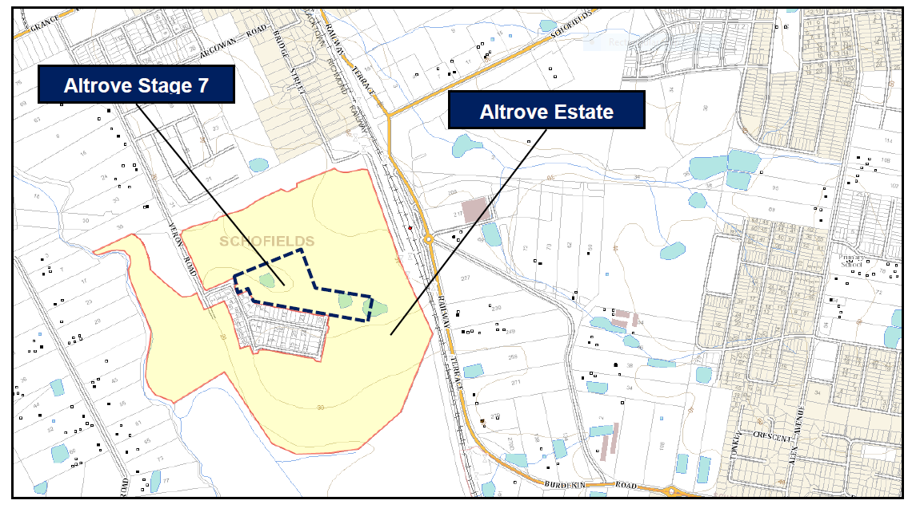

Figure 1: Site location

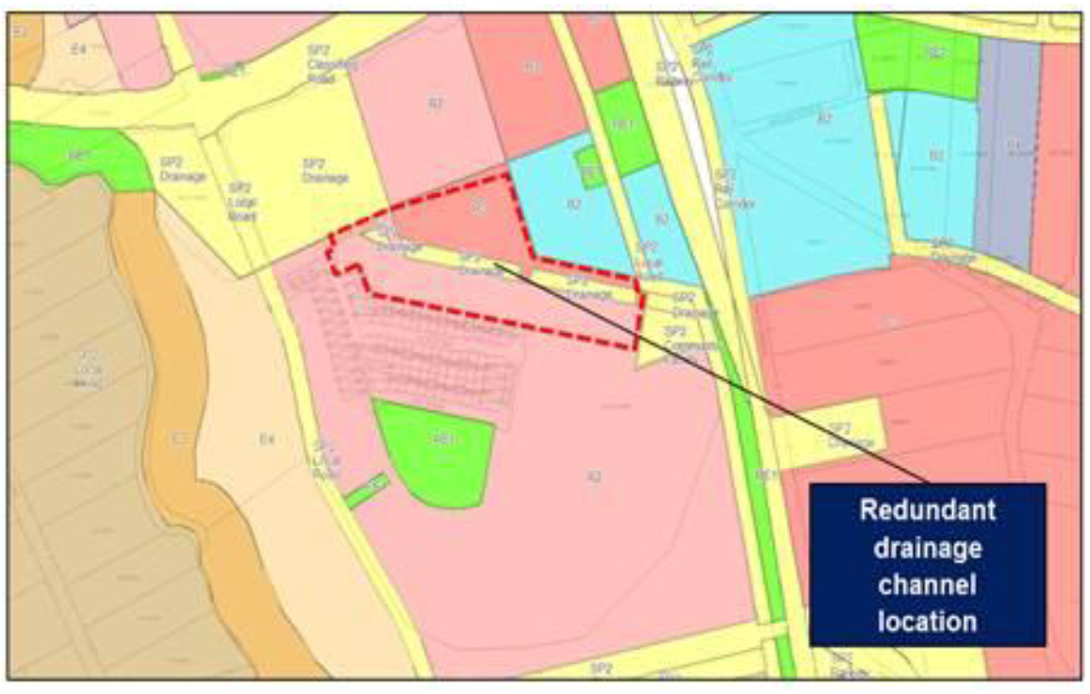

Figure 2: Existing Zoning – SP2 Infrastructure (Drainage).

1. **Purpose of Plan**

The draft LEP seeks to:

* rezone redundant trunk drainage land from SP2 Infrastructure (Drainage) to part R2 - Low Density Residential and part R3 Medium Density Residential;
* apply a maximum height of building control of 9m to the proposed R2 land, and 16m to the proposed R3 land;
* apply a floor space ratio control of 1.75:1 for the proposed R3 land;
* apply a Residential Density of 15 dwellings per hectare to the proposed R2 land, and 40 dwellings per hectare to the proposed R3 land; and
* to remove the land zoned SP2 Infrastructure (Drainage), given the drainage function of this land is redundant, from the Land Reservation and Acquisition mapping.

The rezoning of SP2 land to residential land (R2 and R3) will result in approximately 582sqm of proposed R2 land, and 6370sqm of proposed R3 land. The rezoning will result in approximately 27 additional dwellings.

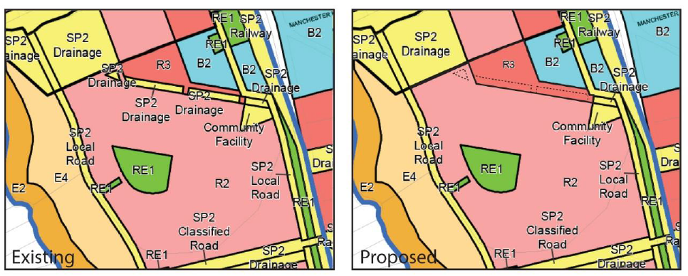

Figure 3: Changes to land zoning - SP2 Infrastructure (Drainage) to R2 and R3.

1. **State Electorate and Local Member**

The site falls within the Riverstone Electorate. Mr Kevin Conolly MP is the State Member for Riverstone.

The Hon Ed Husic MP is the Federal Member for Chiefly.

To the regional planning team’s knowledge, neither MP has made any written representations regarding the proposal.

**NSW Government Lobbyist Code of Conduct:** There have been no meetings or communications with registered lobbyists with respect to this proposal.

**NSW Government reportable political donation:** There are no donations or gifts to disclose and a political donation disclosure is not required.

1. **GATEWAY DETERMINATION AND ALTERATIONS**

The Gateway determination issued on 7 August 2017 **(Attachment C)** determined that the proposal should proceed subject to conditions. The Gateway determination was altered on 6 August 2018 to extend time for completion.

The proposal is due for finalisation 17 November 2018.

1. **PUBLIC EXHIBITION**

In accordance with the Gateway determination, the proposal was publicly exhibited by Council from 8 November 2017 to 6 December 2017. No submissions were received by Council during exhibition.

1. **ADVICE FROM PUBLIC AUTHORITIES**

|  |
| --- |
| Council consulted Transport for NSW, Office of Environment and Heritage, NSW Heritage Council, Sydney Water and DPI - Water in accordance with the Gateway determination. No objections were made by the authorities consulted, however comments were given related to future development applications for the site. |

1. **POST-EXHIBITION CHANGES**

No amendments were made to the planning proposal following public exhibition.

1. **ASSESSMENT**

In accordance with condition 1 of the Gateway determination **(Attachment C)**, the planning proposal was updated to address the following:

* the need for open space for the proposed additional residential dwellings;
* justify the loss of vegetated drainage corridor and linkages that provide aesthetic and ecological values in the area; and
* address the Department’s Land Use Infrastructure and Implementation Plan (LUIIP) and associated amendments.

The proposal was forwarded to the Department for endorsements prior to community consultation. The Department’s endorsement was given on 25 October 2017.

In accordance with condition 2 of the Gateway determination **(Attachment C)**, the consistency of the planning proposal with the following section 9.1 Directions is addressed as follows:

Direction 4.3 Flood Prone Land

This Direction aims to ensure that development of flood prone land is consistent with the NSW Government’s Flood Prone Land Policy and that potential flood impacts are considered.

The Development Control Map level in the Growth Centres SEPP serves to identify the extent of the post development 1 in 100 year flood level. This map applies to the area of SP2 zoned land proposed to be rezoned to R2 and R3. This area of land was identified as being affected by flooding as it follows an existing depression that conveyed overland flows between two farm dams. Council has since approved the filling of this depression in through a development application (DA) for the site (DA-16- 3946).

This DA also approved the construction of Road No. 7A that has been specifically designed to convey stormwater flows in both the minor and major flood events with all flood impacts contained within the road reserve with no impact on upstream or downstream land.

In assessing DA-16-3946 and the Stormwater Management Report, Council was satisfied the proposed road drainage system of Road No. 7A, provided in lieu of the drainage channel, appropriately managed flood risk in this area. Council considered this land is now not needed for drainage purposes. The Planning Proposal is therefore seeking to reflect the development decisions made over this land.

The Department’s Land Release Team was consulted at Gateway stage and has agreed with the proposed rezoning to residential.

State environmental planning policies

The planning proposal is consistent with all relevant SEPPs.

State, regional and district plans

The Planning Proposal is consistent with the objectives outlined in the Central City District Plan, in that it will support to accelerate housing supply, choice and affordability and build great places to live, and will not reduce or significantly impact on identified open space requirements in the area.

1. **MAPPING**

The amending maps to the Growth Centres SEPP Land Zoning, Floor Space Ratio, Dwelling Density, Height of Buildings and Land Reservation Acquisition Maps (Sheet 005) **(Attachment Maps)** have been checked by the Department’s ePlanning Team and were sent to Parliamentary Counsel.

1. **CONSULTATION WITH COUNCIL**

Council was consulted on the terms of the draft instrument under clause 3.36(1) of the *Environmental Planning and Assessment Act 1979***.** Council confirmed on 4 December 2018 that the plan should be made **(Attachment E).**

1. **Parliamentary Counsel Opinion**

On 4 December 2018 Parliamentary Counsel provided the final Opinion that the draft LEP could legally be made. This Opinion is provided at **Attachment PC**.

1. **RECOMMENDATION**

It is recommended that the Greater Sydney Commission’s delegate as the local plan-making authority determine to make the draft LEP under clause 3.36(2)(a) of the Act because:

* All relevant flooding information has adequately been addressed as part of previous development applications, resulting in filling of the site;
* the rezoning to residential will not reduce or significantly impact the need for open space in the area;
* the land will be rezoned for residential land, allowing greater housing supply in an appropriate location; and
* there are no significant environmental, social or economic impacts anticipated as a result of the amendments sought.

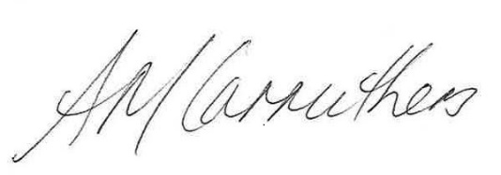

24/01/2019

**Cho Cho Myint Ann-Maree Carruthers**

**Senior Planner Director, Sydney Region West**

**Sydney Region West Planning Services**